1. install eclipse

2. place project Login-Twitter in eclipse-workspace

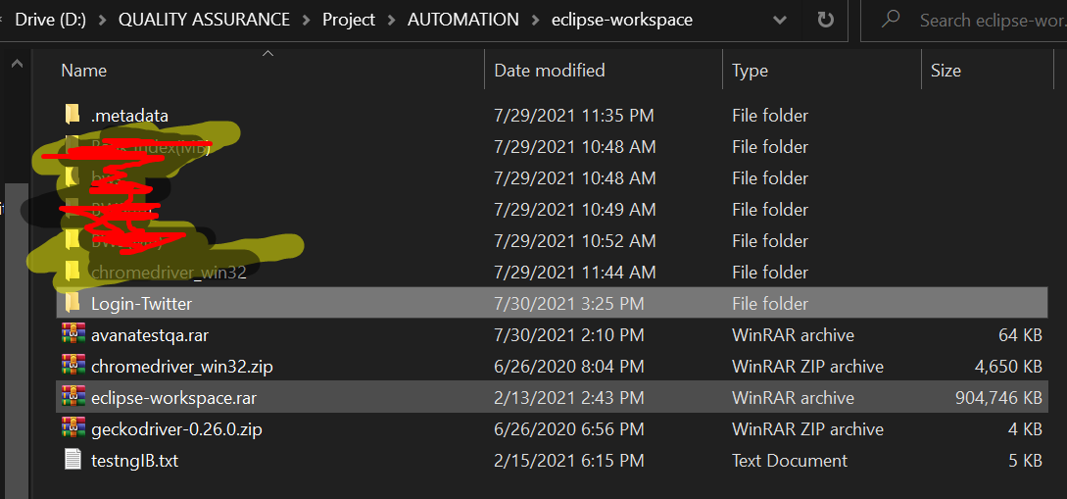

adjust the chrome driver customize directory name in LoginTest.java -> Public Void BeforeTest in place your laptop or computer **(if chrome in your laptop version 93.0.4577.15 you can download new chrome driver ini this url** [**https://chromedriver.storage.googleapis.com/index.html?path=93.0.4577.15/**](https://chromedriver.storage.googleapis.com/index.html?path=93.0.4577.15/) **and place in your directory laptop or youre chrome in another version you can download in this url** [**https://chromedriver.chromium.org/downloads**](https://chromedriver.chromium.org/downloads) **)**

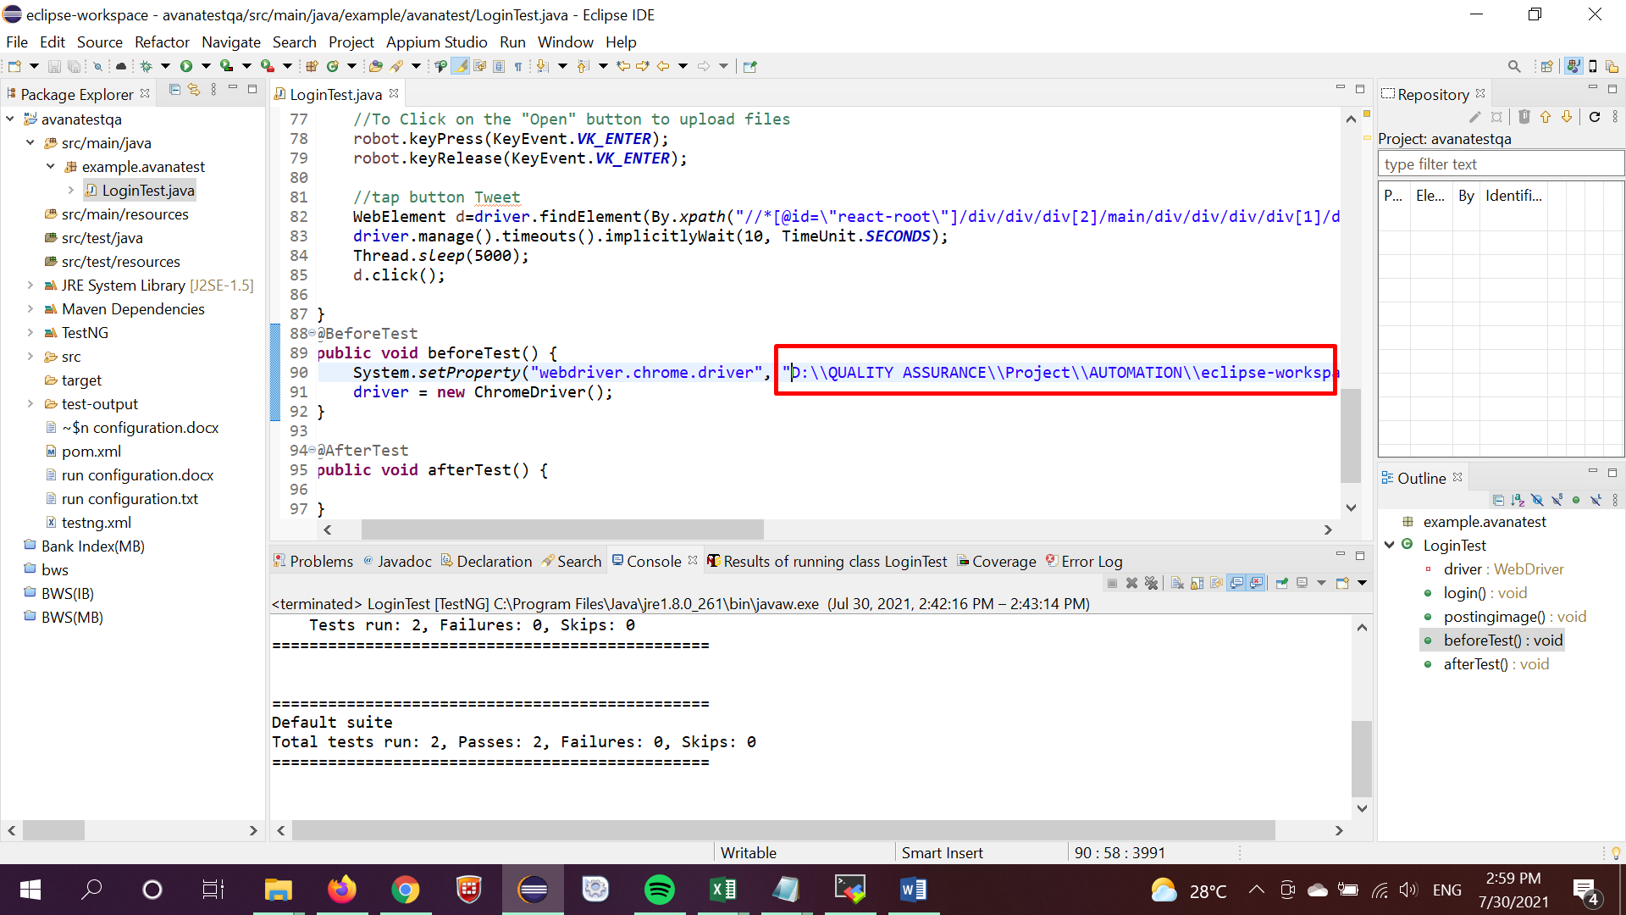

adjust the photo customize directory name in LoginTest.java -> public void postingimage() in place your laptop or computer

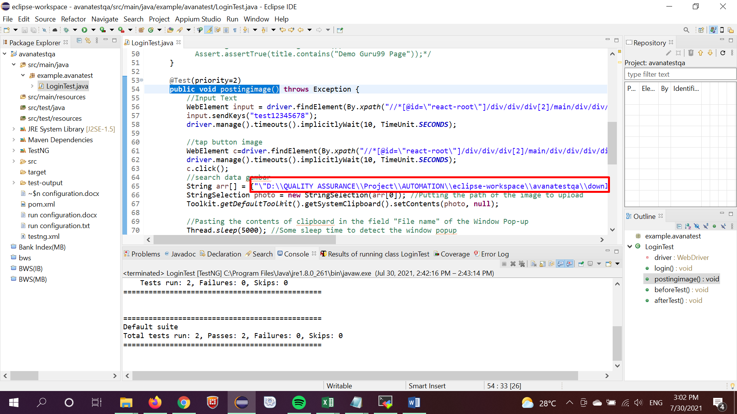

3. import project avanatestqa

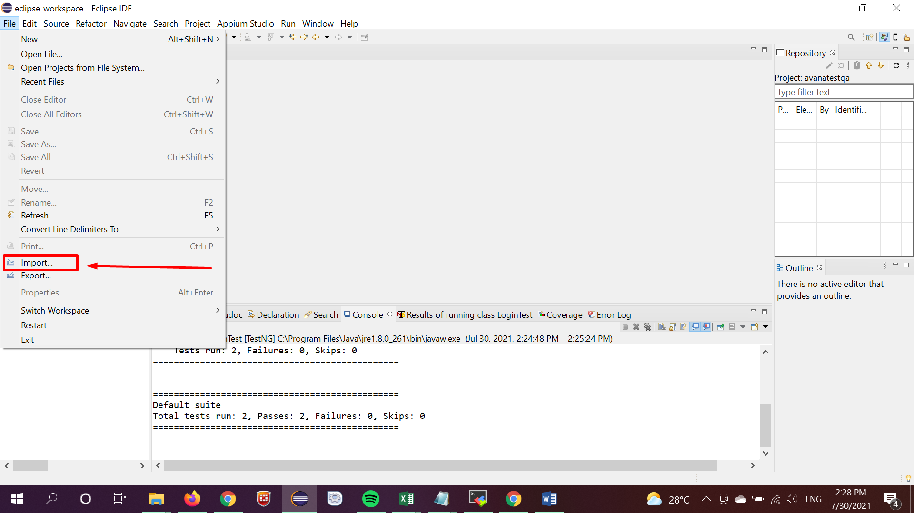

4. chosen Maven -> Existing Maven Projects -> next

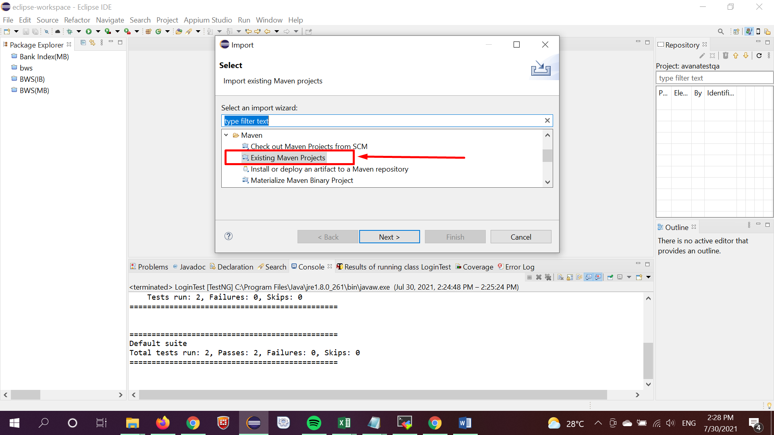

5. browse directory avanatestqa and chosen

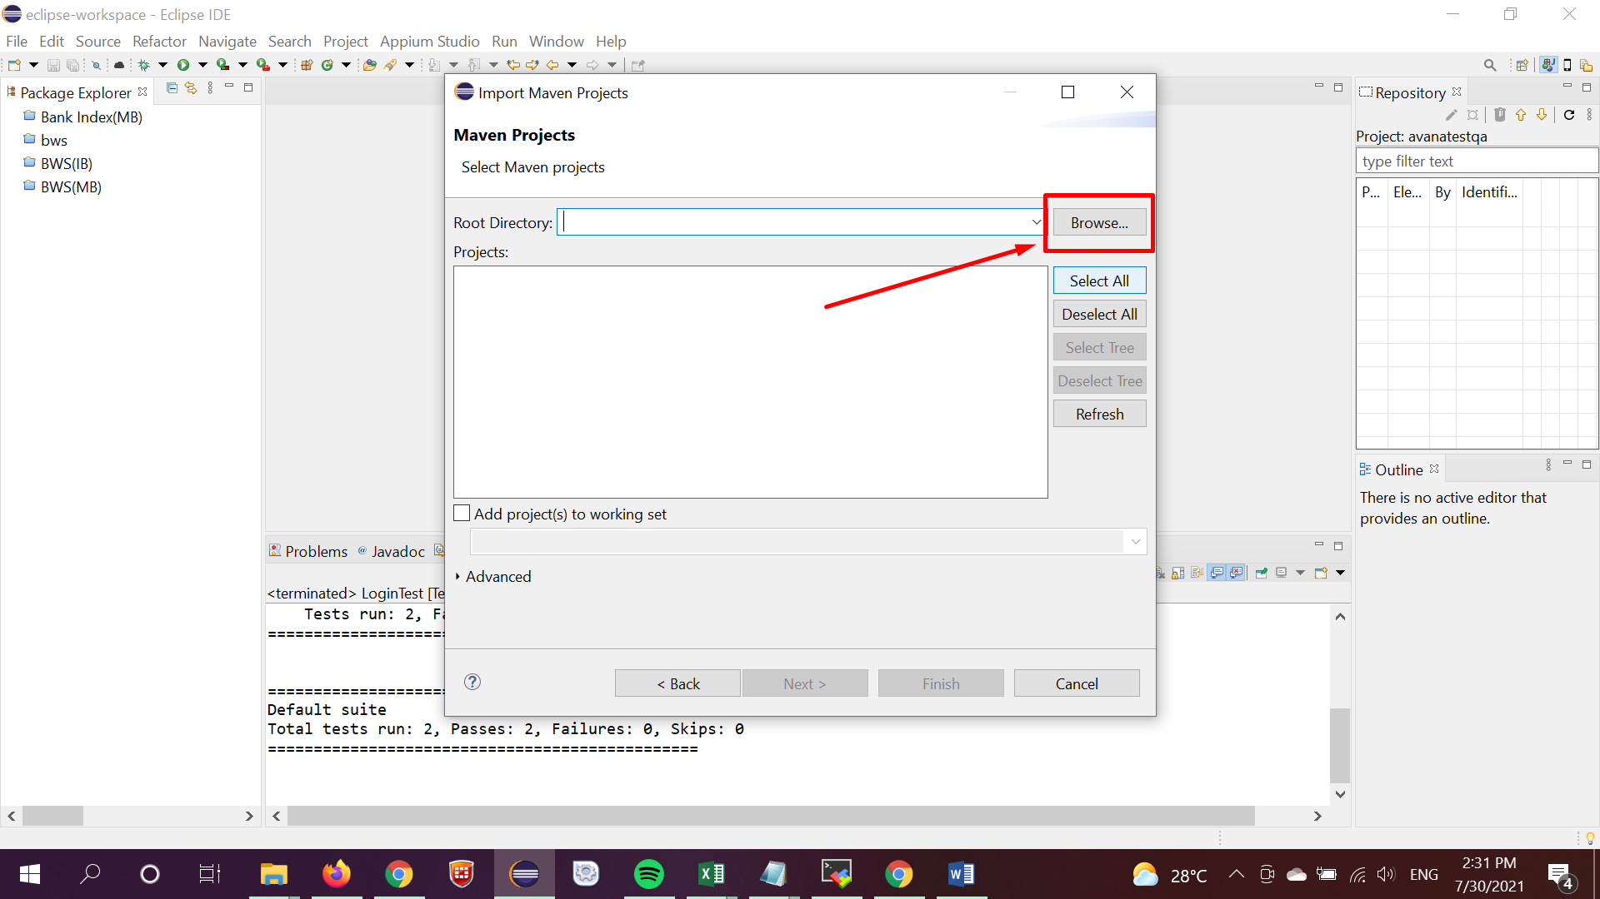



6. klik button finish

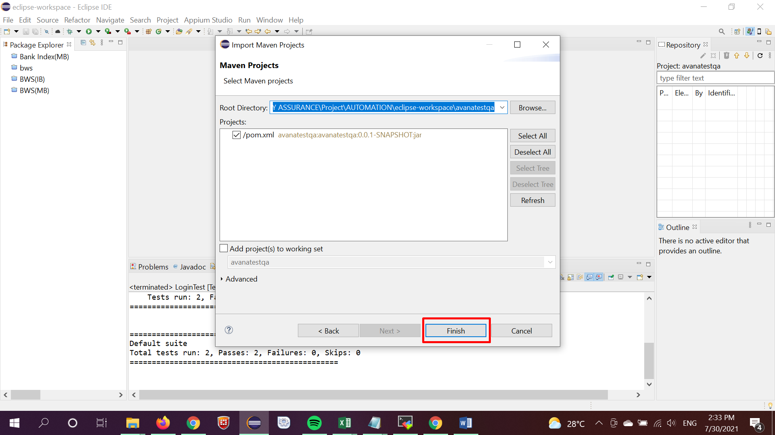

7. wait project build

8. run klik right in file testng.xml -> Run As -> Tesng suite

